INST 354

Sang Hwa Lee

September 15, 2022

LAB 3

**Question 1: Suppose that you are deciding whether to buy a $1 lottery ticket. The jackpot is 1.2 million and there is a 1/1,000,000 chance of winning.**

1. **What are the alternatives in this decision?**

* In this situation, the alternative is to decide whether to buy a $1 lottery ticket or not.

1. **What is the objective?**

* The objective is to find a decision on whether buying a lottery ticket is the right decision or not.

1. **What are the possible consequences or future events?**

* There are two main possible outcomes or future events.

1. *Purchase a lottery ticket. 2. Do not purchase lottery ticket.*

If we consider the results for the event that purchased the lottery ticket,

1. *Win the lottery. 2. No win the lottery (i.e., lose one dollar)*

This can organize the results of possible consequences or future events.

1. **Draw the decision tree for this problem.**

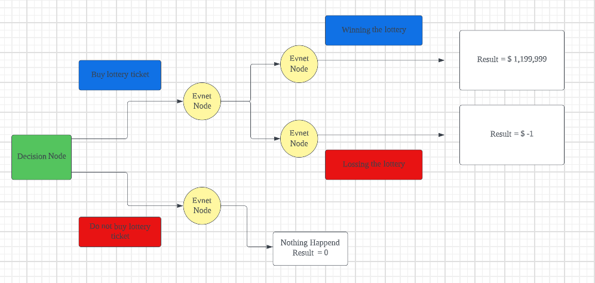

1. **"Roll back" the tree and compute the expected values of each alternative.**
2. EV of buying ticket

(Probability of winning * payoff of winning) + (Probability of losing * payoff of losing)

(1/ 1,000,000 * 1,199,999) + [(1- (1/1,000,000)) * (-1)] =

= (1.199999) + [(1- (0.000001)) * (-1)]

= (1.199999) + [(0.999999) * (-1)]

= (1.199999) + (-0.999999)

= 0.2

1. EV of not buying tickets = 0

**Question 2**

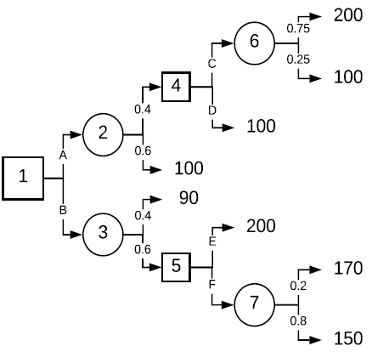

**1. What do nodes 1, 4, and 5 represent? What do nodes 2, 3, 6, and 7 represent?**

1,4,5 – Decision node 2,3,6,7 – Event node

**2. What are the correct original and subsequent decisions based on an expected value criteria? Show your calculations.**

C: (0.75 * 200) + (0.25 * 100) = 150 + 25 = 175 / D: 100

Then, 175 > 100 => Choose the alternative C

E: 200 / F: (0.2 * 170) + (0.8 * 150) = 34 + 120 = 154

Then, 200 > 154 => Choose the alternative E

A: (0.4 * 175) + (0.6 * 100) = 70 + 60 = 130

B: (0.4 * 90) + (0.6 * 200) = 36 + 120 = 156

Then, 156 > 130 => Choose the alternative B

**3. What is the overall expected value for this decision problem?**

**Alternative B is the best alternative at the first stage.**